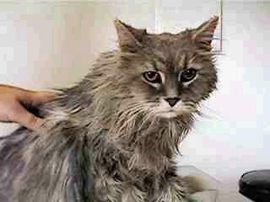
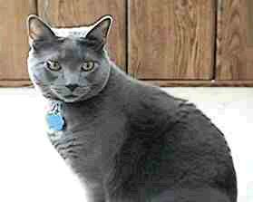
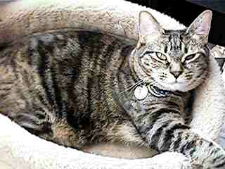
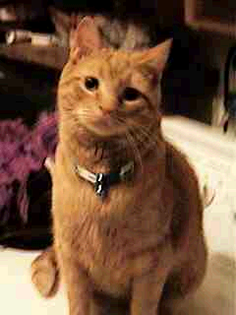
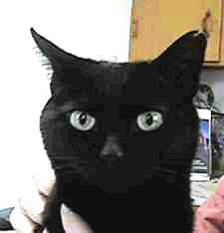
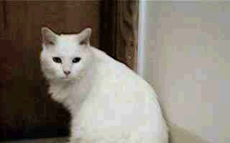
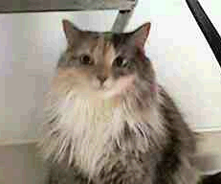
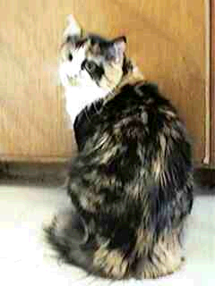Welcome to State College Veterinary Hospital

NEW CLIENT/PATIENT INFORMATION

CLIENT INFORMATION DATE
LAST NAME FIRST TITLE

ADDRESS PHONE ______ EMAIL

CITY STATE ZIP SPOUSE

OCCUPATION/EMPLOYER PHONE

BUSINESS ADDRESS

DRIVER’S LICENSE NUMBER STATE
(for check cashing purposes)
PAYMENT IS EXPECTED AT THE TIME SERVICES ARE RENDERED.
WE ACCEPT CASH, CHECKS, MASTER CARD, VISA, DISCOVER, AMEX & CARE CREDIT.

PATIENT INFORMATION (AS MUCH AS YOU KNOW)

NAME SEX SPAYED/NEUTERED? Y/N DATE OF BIRTH

BREED COLOR MARKINGS

(circle one) DOES YOUR CAT STAY…. INDOORS AT ALL TIMES/MIXED IN & OUT/OUTDOORS AT ALL TIMES
DECLAWED?……..Front_____Hind _____

DATE OF LAST VACCINATIONS:
FVR/CP-PN RABIES 1 OR 3 YEAR IF APPLICABLE
FELV _____ FIP TESTED FOR FELV/FIV?

IS YOUR CAT ON HEARTWORM PREVENTION? IF SO, YEAR-ROUND OR SEASONAL

ANY SURGERY, MAJOR ILLNESS, OR ALLERGIES?

DRUG HYPERSENSITIVIES

DOES YOUR CAT HAVE A PET INSURANCE POLICY? Y/N COMPANY: POLICY #:

EMERGENCY CONTACT PHONE

NAME OF OTHER PETS

HOW DID YOU CHOOSE OUR HOSPITAL? IF REFERRAL, WHO?
----------------------------------------------------------------------------------------------------------------------------------------------------------------------------------------------------------
Photo Release Form

I, ________________________________________________, grant to State College Veterinary Hospital, its representatives and employees the right to take photographs of me and/or my pet to use and publish in print and/or electronically.

I agree that State College Veterinary Hospital may use such photographs of me and/or my pet with or without my name for any lawful purpose, including purposes such as publicity, illustration, advertising, and Web content.

I understand that no compensation will be provided for such images.

❍ The above may take photos of me and/or my pet ❍ The above may NOT take photos of me and/or my pet

Printed name: ________________________________________________________________________ Signature: _______________________________________________________________________________________

